IT 202 Project Two Five Tickets

This document contains the five ticket submissions received by the help desk that you work for. The information in these tickets is fictional to provide you with practice as to what an actual IT help desk ticket looks like in the profession. While some of the information on the tickets is necessary for you to troubleshoot, other information is for additional context.

Ticket number INC0352668

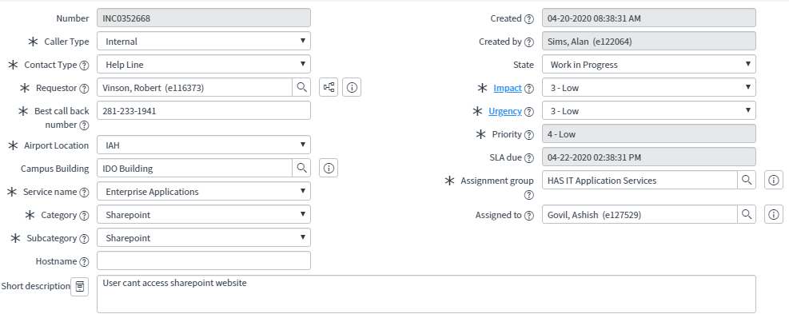

Ticket Number INC0354837

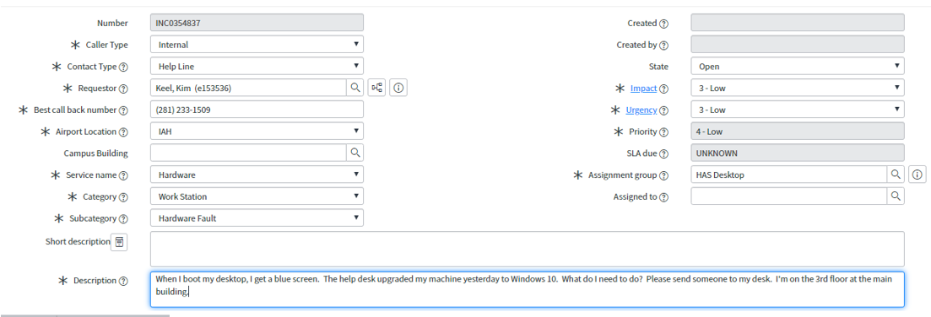

Ticket Number INC0352699

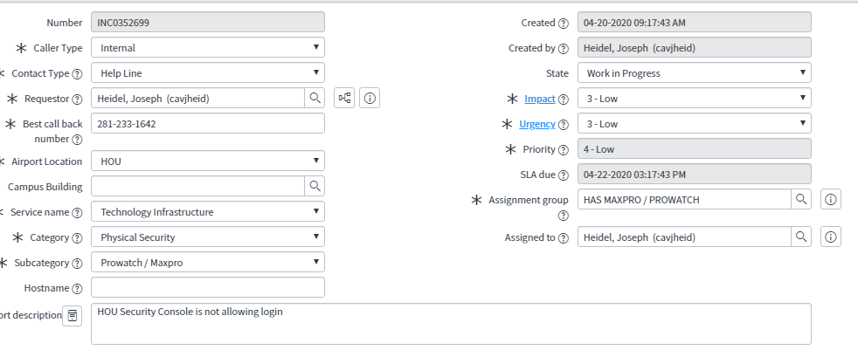

Ticket Number INC0352723

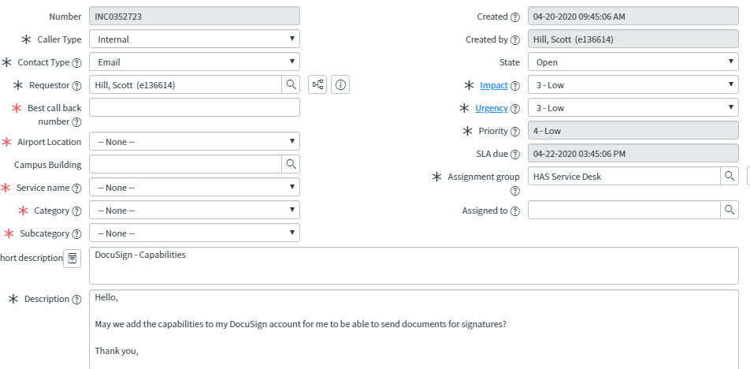

Ticket Number INC035946

